FunImgARCW_subject1
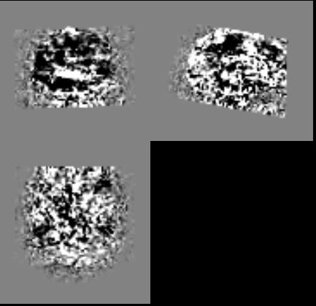
FunImgARCW_subject2
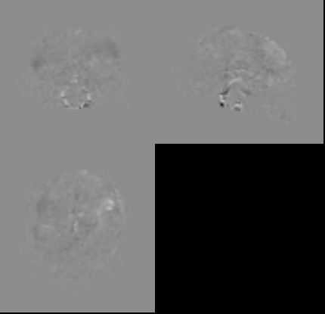

PicturesForChkNormalization_subject1
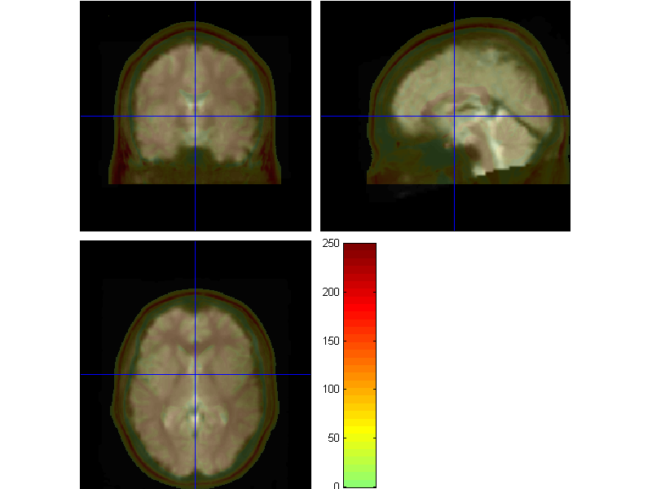
PicturesForChkNormalization_subject2

